SF Elite Air Quality and Excessive Heat Policy
This policy is designed to set the criteria upon which league games and/or training sessions will be canceled during periods of excessive heat and/or periods of poor air quality. Protecting players, coaches and parents from excessive heat during and/or poor air quality is a critical part of a well-run organization. Maintaining the health and safety of all club participants (staff and members) is always at the forefront of the club’s operations.
Air Quality
There are three reasons why otherwise healthy athletes are at special risk for inhaling pollutants. First, as physical activity increases minute ventilation, the number of pollutants that are inhaled relative to when the athlete is at rest are increased. Second, during activity, a larger proportion of air is inhaled through the mouth, which bypasses the body’s built-in nasal filtration system. Third, pollutants are inhaled more deeply and may diffuse into the bloodstream more quickly during physical activity. These risks are heightened in athletes with pre-existing pulmonary or cardiac conditions.
An important and standardized national air quality resource is the National Weather Service’s (NWS) Air Quality Forecast System. This system “provides the US with ozone, particulate matter and other pollutant forecasts with enough accuracy and advance notice to take action to prevent or reduce adverse effects.”
A key component of this forecast system is the NWS Air Quality Index (AQI). The AQI provides real-time monitoring and alerts in response to changing air quality levels. The AQI accounts for five different pollutants, including: 1) ground-level ozone; 2) particle pollution (also known as particulate matter); 3) carbon monoxide; 4) sulfur dioxide; and 5) nitrogen dioxide. Of these, ground-level ozone and particulate matter are the most common and most concerning pollutants for outdoor physical activity. The AQI is a single number, presented on a scale of 0 – 500, where 0 indicated no air quality problems and 500 indicates the most hazardous levels of air pollution. A specialized version of the AQI for particle pollution is also available and should be consulted in those situations when threats to air quality come from wildfires, road dust, and agricultural operations.
When threatening or dangerous air quality levels are present the AQI increases, and the National Weather Service (NWS) issues a corresponding air quality alert. Those alerts and their corresponding behavioral modification recommendations for particle pollution can be found
at https://www.airnow.gov.
Consistent with this information, Davis Legacy Soccer Club is instituting the following general guidelines that all teams, members and staff shall follow to make decisions about the appropriateness of holding practice or competitions in during periods of air quality concerns:
- ● Practices and games will continue at all times in the 0-100 range
- ● Practices and games will continue when the air quality is in the 100-150 range, however
players who choose not to attend will not be penalized as the air quality becomes
challenging for those in the ‘sensitive groups’.
- ● Practices and games will be canceled for all ages when air quality is 150 or higher.
DLSC will rely on real-time data from the AirNow UC Davis monitoring station and will use the national standards as established by the EPA at www.airnow.gov. The scale is as follows:
Excessive Heat
DLSC has adopted the Heat and Water Break Guidelines as outlined in the following National Athletic Trainers Association document.
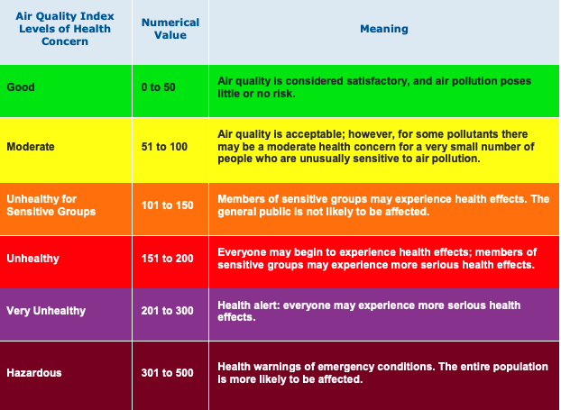
Dehydration
Parents’ and Coaches’ Guide to Dehydration and Other
Heat Illnesses in Children
These guidelines were developed to help parents and coaches increase the safety and performance of children who play sports in hot weather. Children who play sports or are physically active in hot weather can be at risk for heat illnesses. The good news is heat illnesses can be prevented and successfully treated.
Children sweat less than adults. This makes it harder for children to cool off. Parents and coaches must make sure that children take it slow to be sure they can get used to the heat and humidity gradually.
There are other reasons why a child may become ill from a heat illness. Those who have a low level of fitness, who are sick, or who have suffered from dehydration or heat illness in the past should be closely watched. A medical professional such as a certified athletic trainer (ATC) should be on site to monitor the health and safety of all participants during games and practice, especially when it is very hot and humid.
Children get dehydrated if they do not replace body fluids lost by sweating. Being even a little dehydrated can make a child feel bad and play less effectively. Dehydration also puts children at risk for more dangerous heat illnesses.
Signs and Symptoms
x Dry mouth
x Thirst
x Being irritable or cranky
x Headache
x Seeming bored or disinterested
x Dizziness
x Cramps
x Excessive fatigue
x Child not able to run as fast or play as well as usual
Treatment
x Move child to a shaded or air-conditioned area. x Give him or her fluids to drink.
"When can I play again?"
A child may be active again as soon as he or she is symptom-free. However, it’s important to continue to watch the child.
Heat Cramps
Heat Exhaustion
Heat cramps are a mild heat illness that can be easily treated. These intense muscle spasms usually develop after a child has been exercising for a while and has lost large amounts of fluid and salt from sweating. While heat cramps are more common in children who perform in the heat, they can also occur when it’s not hot (for example, during ice hockey or swimming).
Children who sweat a lot or have a high concentration of salt in their sweat may be more likely to get heat cramps. Heat cramps can largely be avoided by being adequately conditioned, getting used to the heat and humidity slowly, and being sure a child eats and drinks properly.
Signs and Symptoms
x Intense pain (not associated with pulling or straining a muscle)
x Persistent muscle contractions that continue during and after exercise
Treatment
x The child should be given a sports drink to help replace fluid and sodium losses. x Light stretching, relaxation and massage of the cramped muscles may help.
"When can I play again?"
A child may be active again when the cramp has gone away and he or she feels and acts ready to participate. You can help decrease the risk of recurring heat cramps by checking whether the child needs to change eating and drinking habits, become more fit, or get better adjusted to the heat.
Heat exhaustion is a moderate heat illness that occurs when a child continues to be physically active even after he or she starts suffering from ill effects of the heat, like dehydration. The child’s body struggles to keep up with the demands, leading to heat exhaustion.
Signs and Symptoms
x Child finds it hard or impossible to keep playing x Loss of coordination, dizziness or fainting
x Dehydration
x Profuse sweating or pale skin
x Headache, nausea, vomiting or diarrhea
x Stomach/intestinal cramps or persistent muscle cramps
Treatment
x Move child to a shaded or air-conditioned area.
x Remove any extra clothing and equipment.
x Cool the child with cold water, fans or cold towels (replace towels frequently).
x Have child lie comfortably with legs raised above heart level.
x If the child is not nauseated or vomiting, have him or her drink chilled water or sports drink. x The child’s condition should improve rapidly, but if there is little or no improvement, take the
child for emergency medical treatment.
"When can I play again?"
A child should not be allowed to return to play until all symptoms of heat exhaustion and dehydration are gone. Avoid intense practice in heat until at least the next day, and if heat exhaustion was severe, wait longer. If the child received emergency medical treatment, he or she should not be allowed to return until his or her doctor approves and gives specific return-to-play instructions.
Parents and coaches should rule out any other conditions or illnesses that may predispose the child for continued problems with heat exhaustion. Correct these problems before the child returns to full participation in the heat, especially for sports with equipment.
Exertional Heat Stroke
Parents: How Much Should Your Child Drink When Active?
x Before activity in the heat, record your child’s body weight. (Remember if your child has already been exercising in the heat, he or she may already be dehydrated.)
x Weigh your child again, after the activity is over.
x Compare your child’s pre- activity body weight to his or her post-activity body weight.
If post-activity weight is less than pre-activity weight, your child is not drinking enough fluids while active. A loss of as little as 1 percent of body weight can cause a decrease in performance. Because scientists have proven that children replace less of their fluid losses when drinking water, you may want to offer a flavored sports drink to increase the amount of fluid your
child consumes.
Heat stroke is a severe heat illness that occurs when a child’s body creates more heat than it can release, due to the strain of exercising in the heat. This results in a rapid increase in core body temperature, which can lead to permanent disability or even death if left untreated.
Signs and Symptoms
x Increase in core body temperature, usually above 104°F/40°C (rectal temperature) when the child falls ill
x Central nervous system dysfunction, such as altered consciousness, seizures, confusion, emotional instability, irrational behavior or decreased mental acuity
Other possible indicators include:
x Nausea, vomiting or diarrhea
x Headache, dizziness or weakness
x Hot and wet or dry skin
x Increased heart rate, decreased blood pressure or fast breathing x Dehydration
x Combativeness
Treatment
If there are no on-site medical personnel:
x Call emergency medical services for immediate
transport to the nearest emergency medical facility. Begin cooling the child while waiting for and during transport to the emergency facility.
If there are on-site medical personnel:
x Locate medical personnel immediately. Remove
extra clothing or equipment. Begin aggressive whole-body cooling by immersing the child in a tub of cold water. If a tub is not available, use alternative cooling methods such as cold water, fans, ice or cold towels (replaced frequently), placed over as much of the body as possible.
x Call emergency medical services for transport to the nearest emergency medical facility.
"When can I play again?"
No child who has suffered heat stroke should be allowed to return until his or her doctor approves and gives specific return-to-play instructions. Parents should work with the child’s doctor to rule out or treat any other conditions or illnesses that may cause continued problems with heat stroke. The child should return to physical activity slowly, under the supervision of an ATC or other qualified health care professional, especially for sports with equipment.
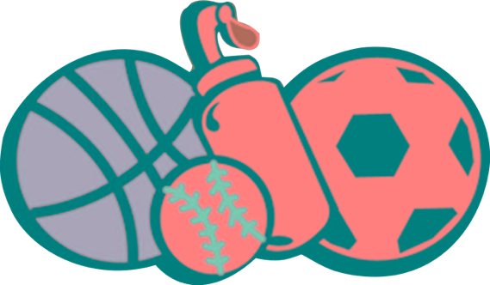
Tips for Parents
Tips for Coaches
Activity Guidelines
D
C
B
A
x Before your child starts playing a sport, he or she should have a physical examination that includes specific questions about any history of heat illness.
x Tell your child’s coach about any history of heat illness.
x Make sure your child is properly hydrated before he or she heads out the door to practice or
a game. Give your children their own water bottles.
x Make sure your child’s coach has your emergency contact numbers. x Check that your child’s league/team has an emergency action plan.
x Be aware of temperature and humidity levels. Change practice length, intensity and equipment use as the levels rise.
x It should be easy for children to drink fluids during practice, and you should remind them to drink regularly. Fluid breaks should be scheduled for all practices and become more frequent as the heat and humidity levels rise.
x Every athletic organization should have an emergency action plan for obtaining emergency medical services if needed.
x Always have contact information for parents available.
Fluid breaks should be scheduled for all practices and become more frequent as the heat and humidity levels rise.
Add 5°F to the temperature between 10:00 a.m. and 4:00 p.m. from mid-May to mid-September on bright, sunny days.
- Children should receive 100 a 5-10 minute rest and 90 fluid break after every
25 to 30 minutes of 80 activity. 70
- Children should receive 60 a 5-10 minute rest and 50 fluid break after every
20 to 25 minutes of 40 activity. Children should 30 be in shorts and t-shirts
(with helmet and 20 shoulder pads only, 10 not full equipment,
if worn for activity). 0
C.
D.
Children should receive a 5-10 minute rest and fluid break after every 15 to 20 minutes of activity. Children should be in shorts and t-shirts only (with all protective equipment removed,
if worn for activity).
Cancel or postpone all outdoor practices/games. Practice may be held in an air-conditioned space.
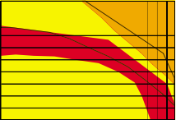
70 74 78 82 86 90 94 98 102
Temperature (°F)
This document was adapted from: Inter-Association task force on exertional heat illnesses consensus statement. June 2003. National Athletic Trainers’ Association. The full document can be obtained at www.nata.org/industryresources/heatillnessconsensusstatement.pdf.

